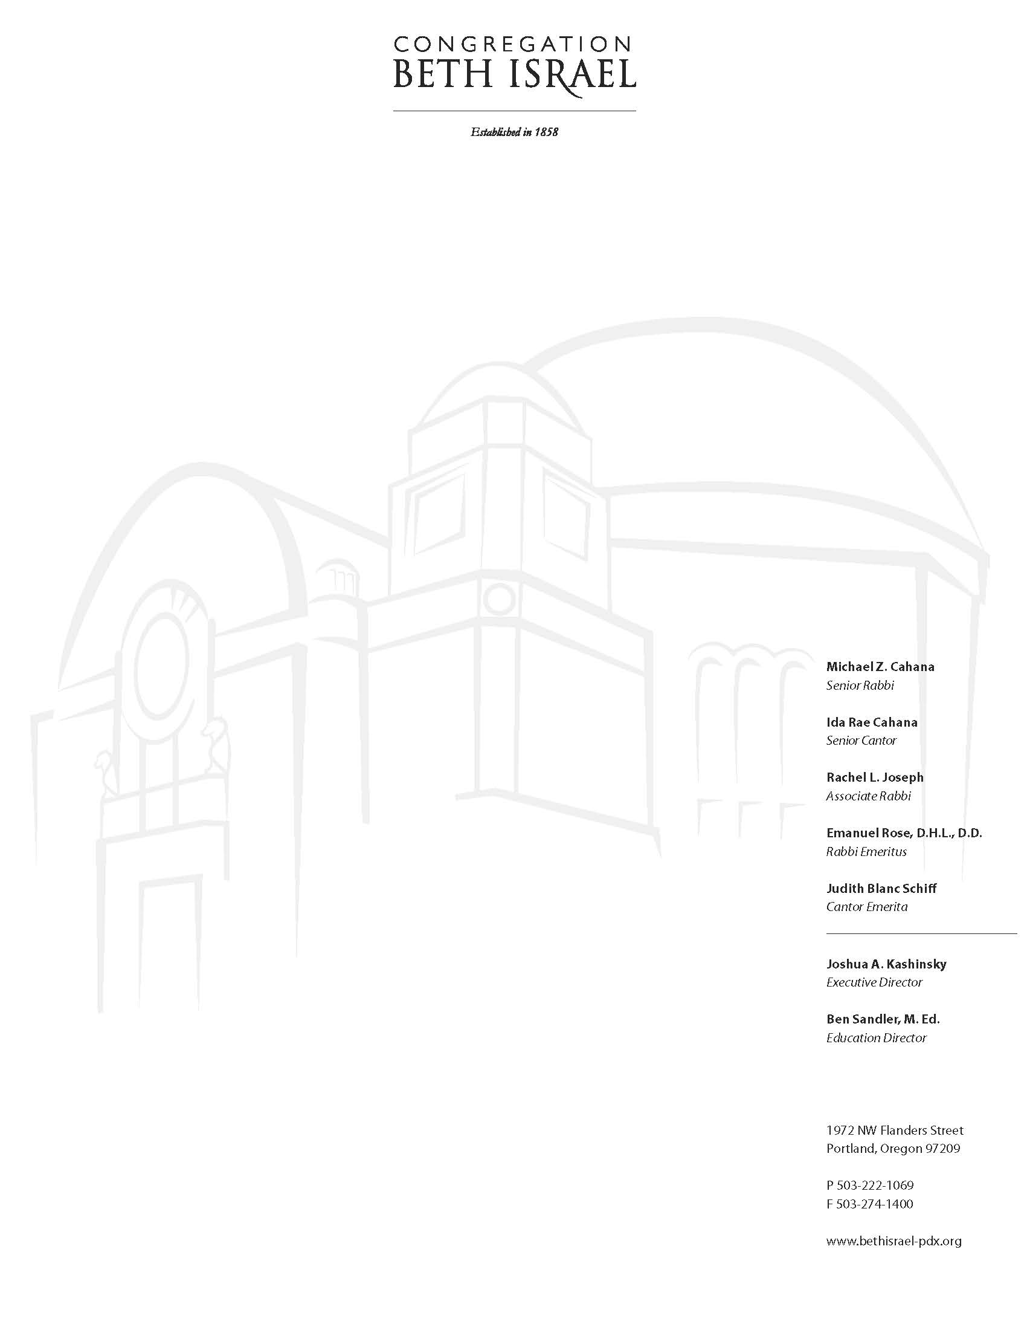

January 24, 2019

It is with great joy and anticipation that we join with you and your family in beginning the journey for your child’s Bar or Bat Mitzvah*.* This is a milestone experience of your child’s Jewish journey, which leads them to Confirmation, through High School and beyond.

We know it may be surprising, since your child is just in third grade this year, but it is actually time to start thinking about B’nei Mitzvah. We start tracking Sunday Religious School attendance in third grade. Your child’s experience in religious school in the years leading up to their Bar/Bat Mitzvah will be spent expanding their Jewish knowledge, learning the skills they need to read Hebrew, chant the prayers, and eventually to chant from the Torah scroll itself. The social aspect of religious school is equally important as your children develop friendships with their Jewish peers.

Please review the attached calendar, then go to **http://bit.ly/MitzvahDates** to choose your possible dates. After reviewing holidays and other potential conflicts, we have listed **ONLY** the dates that are actually available. Most B’nei Mitzvah ceremonies are held during 10:30 PM Shabbat Morning Services. There is also an option to hold a Havdalah Bar/Bat Mitzvah service at 5:00 PM on a Saturday.

With this calendar and your family’s schedule or commitments in mind, please choose three possible dates for your child’s Bar or Bat Mitzvah, and indicate if you would prefer a Havdalah service. As it will be increasinglydifficult to change your child’s date once it is scheduled, please take a moment to consider details such as travel for your extended family, extracurricular or work commitments, or any other potentially complicating factors. **Please note that there will always be at least one clergy member in town to lead services, but we cannot guarantee which one.**

Please complete the online form by **Tuesday, February 19**, at which point we will begin placing names on our calendar. If any conflicts arise, such as multiple families requesting the same dates, we will reach out to you and work together to make sure everyone finds a date that works for them. B’nei Mitzvah dates are **NOT** assigned on a first-come, first-served basis; as long as we receive your form by **Tuesday, February 19**, all date requests will be given equal consideration**.** Please take what time you need to consider all your family’s circumstances before submitting the form (by the deadline!).

This process continues on **Sunday, March 3rd** from **10:15 AM to 12:15 PM** with our 3rd Grade Family Program. Our third graders and their parents/guardians will gather as a group with our clergy to confirm the 2022/3 B’nei Mitzvah calendar, and to explain the B’nei Mitzvah experience at CBI. This will include a discussion of what is expected of the student and the family, what training is involved, what requirements and policies are in place, and so on. You will receive email reminders about this event in the next few weeks. As with all good Jewish events, there will be food!

Should you have any questions about this process or need guidance completing the date request form, please feel free to contact Emily: 971-339-2073 or [emily@bethisrael-pdx.org](mailto:emily@bethisrael-pdx.org).

We look forward to working with you now and in the coming years as your child prepares for this next important step on their Jewish journey.

B’shalom,

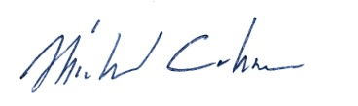 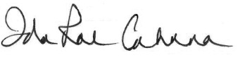 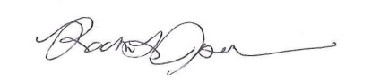

Rabbi Michael Z. Cahana Cantor Ida Rae Cahana Rabbi Rachel L. Joseph

Senior Rabbi Senior Cantor Assistant Rabbi