Vintage Cheesecake
From the kitchen of Sydney Anker Baer
Preheat oven to 350 degrees F.

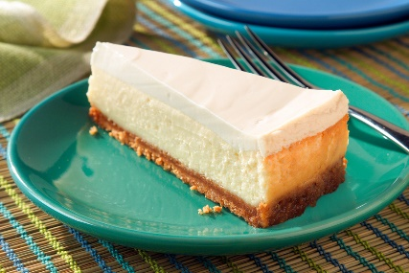

Crust
16 Nabisco “original” graham cracker squares = 1 ¼ cups crushed
(one package within 14.4 oz box)
6 Tbsp. unsalted butter, melted
2 Tbsp. granulated sugar

Filling
2 large eggs
½ cup granulated sugar
9 oz. Philadelphia Original Cream Cheese

Topping
1 cup sour cream
1 Tbsp. granulated sugar
1 tsp. vanilla extract

Crush graham crackers (either in plastic bag with rolling pin or in your Cuisinart. Pour crushed graham crackers into a 9” springform pan. Add melted butter and sugar. Mix with fork until graham cracker mixture looks like wet sand. Press into the bottom of the spring form pan and about an inch up the sides.

In stand mixer with paddle attachment, mix eggs and sugar until fluffy. Add cream cheese in small chunks. Pour cream cheese mixture into graham cracker shell. Bake for about 25 minutes. Let cool.

Combine sour cream, sugar, and vanilla. Spread topping over cooled cheesecake, cook for additional 10 minutes. Refrigerate overnight. Garnish top with a sprinkle of ground nutmeg.

