Our High Holiday Services can be watched on YouTube. The best quality video and sound will be on your TV, not your computer. If you are streaming to your TV (Netflix, etc.) you already have the set-up to watch our videos on YouTube. Here are ways to watch, depending on the kind of internet connection you have to your TV:

Using an Amazon Fire device to watch our YouTube broadcasts
If you have an Amazon Fire TV box, or Fire Stick, select it from the list of sources on your television. Then make sure you have the YouTube app installed and activated.
- Press the home button on your Fire remote
- Using the circular controller above the home button select Apps, then Featured, then Entertainment and find YouTube (NOT YouTube TV). Select it.
- Once you are in YouTube select the search option on the left of the screen and search for Congregation Beth Israel Portland. THE ONE WITH OUR LOGO unless you want to visit Portland Maine, Eugene, Auston, Houston, or somewhere else where we will miss you!
- NOTE: For events occurring on Zoom we suggest you use your PC, not your television, unless you have a video camera build into your TV which (hint) you probably don’t.

Using a Roku device to watch our YouTube broadcasts
If you have a Roku device select it from the list of sources on your television. Then make sure you have the YouTube app installed and activated.
- Press the home button on your Roku remote
- Using the controller, move the cursor to the right side of the display where your apps are listed, Then find and select YouTube.
- Once you are in YouTube select the search option on the left of the screen and search for Congregation Beth Israel. THE ONE WITH OUR LOGO unless you want to visit Portland, Eugene, Auston, Houston, or somewhere else where we will miss you!
- NOTE: For events occurring on Zoom we suggest you use your PC, not your television, unless you have a video camera build into your TV which (hint) you probably don’t.

Connecting your PC to your TV with Chromecast
Some modern televisions have Google’s Chromecast functionality build in. This is a super way to connect, if you are lucky enough to have it.
- Open Google Chrome (This will NOT work in any other browser).
- In the upper right corner, click the rightmost button (which will probably be 3 vertical dots)
- Select “Cast”
- If your TV includes Chromecast, it will show up as an available device.
- Select a Source in the lower left of the dialog box (Browser tab, Desktop, etc.)
- Click on your TV in the list of devices.
- You should now see your PC’s Google Chrome browser displayed on the TV.

Connecting your PC to your TV with a Cable

If you plan to watch services using your Laptop computer connected to your PC you will need one of several cables. Most modern televisions use HDMI which allows audio and video to be connected through a single cable. This is easiest, most common, and the only way that you can get sound to your TV without additional audio cables.
If you have an older Laptop (without HDMI) – you will connect with either VGA or DVI and a separate audio cable. If you don’t have an audio cable the sound will come out of your computer.
In all 3 cases you will need to connect one end of the cable to your PC and the other to your TV using by looking for one of the following connectors.
 | Cable | Connector on your TV
HDMI  (Most likely) | 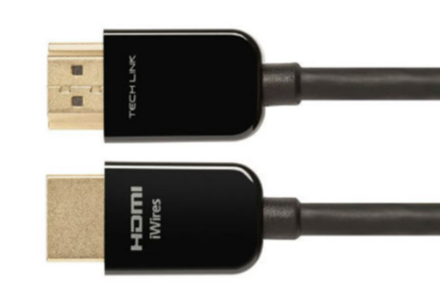 | 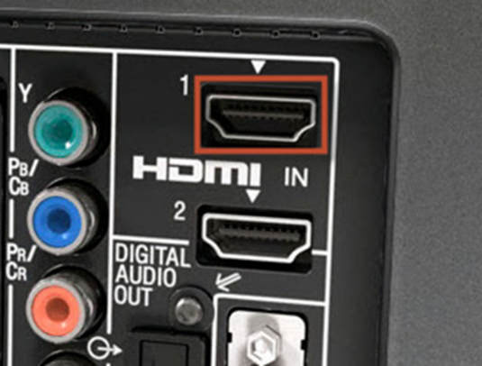
VGA | 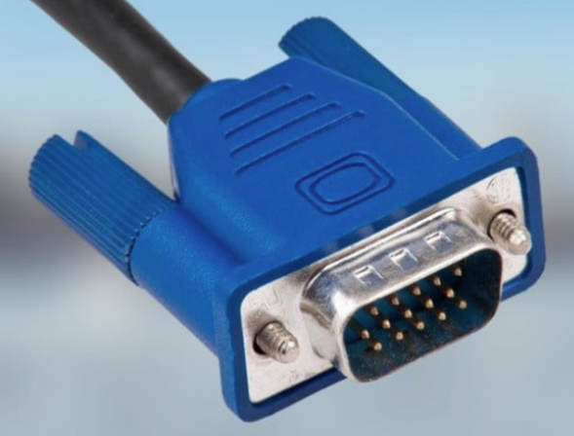 | 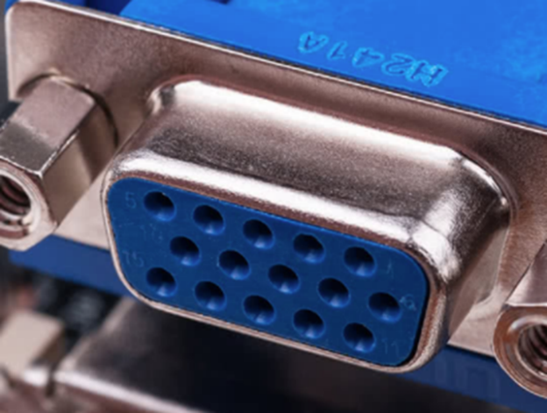
DVI | 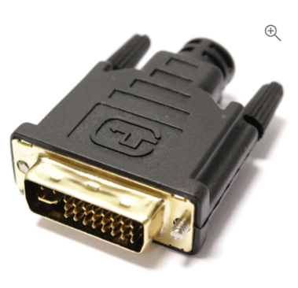 | 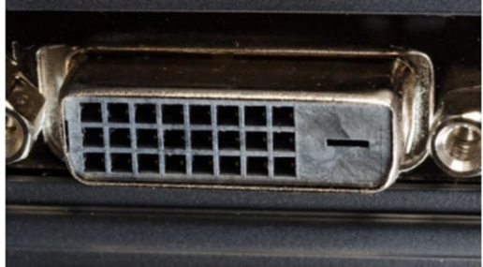

It’s possible that HaShem will look kindly upon you and your TV will just work. If not you may need to configure it. There are many versions of Microsoft Windows and each, unfortunately, has a different way to configure displays. That said, they are all similar. On the current version of Windows 10 you can configure your new TV as a new display by:
- On your desktop right click
- Select “Display Settings”
- You will see at least 2 displays shown and your TV will probably be #2.
- Select your TV
- IF your PC is not already displaying properly on your TV then select “Advanced Display Settings”
- Select “Display Adapter Properties for Display XXX” (Where XXX is your display number for the TV)
- Chick “List All Modes” and then select a resolution and refresh rate. You will probably have to play with this until you find the correct setting.
Alternatively, It’s a good time for repentance.

Watching services on your Computer
- Navigate to the Congregation Beth Israel Website: https://www.bethisrael-pdx.org/
- From the menu at the top, click High Holidays 5781: https://www.bethisrael-pdx.org/cbi5781/
- Scroll down and click on the yellow button that says Rosh Hashanah or Yom Kippur (depending on the holiday you’re looking for)
- Scroll down and click on the button with the name of the service you would like to watch
  - If you want to follow along in the virtual prayer book, click the link that says ‘Click here for the Virtual Prayer book’ beneath the button with the service title on it
- You will be redirected to Youtube to watch the service
Please note that the link will be available at the time listed directly beneath the button with the service title on it. If you are clicking early, it may not work yet.

