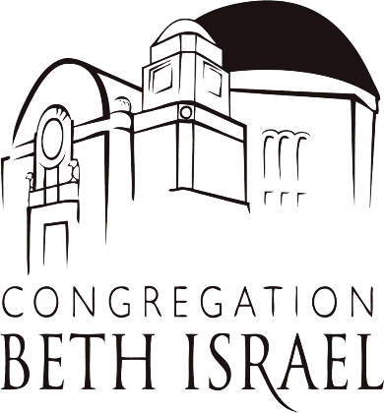
JOB ANNOUNCEMENT: Executive Assistant
OPENING DATE: February 15, 2021
CLOSING DATE: Open Until Filled- Apply Now for Immediate Consideration
SALARY: $20-24/hr, DOE
STATUS: Full-time Regular, Non-Exempt
POSITION SUMMARY: As an Executive Assistant, you will support the Clergy (Senior Rabbi, Senior Cantor, Associate Rabbi, Cantor) and occasionally, the Executive Director and other departments, with business duties. Your responsibilities will include organizing the Clergy’s calendars, scheduling meetings, organizing mailings, and communicating with congregants and community members on behalf of the Clergy. Must be flexible and able to manage projects, as well as maintain confidentiality and a high level of service. Technical skills are required, including facility with spreadsheets and databases, experience with Microsoft Office, familiarity with Zoom, and willingness to learn these programs and other programs at a high level of aptitude. Growth in this role looks like taking on additional duties and growing responsibilities. Organization and flexibility are key!
ESSENTIAL RESPONSIBILITIES AND DUTIES:
- Act as the point of contact between the manager and internal/external clients;
- Screen and direct phone calls and distribute correspondence;
- Screens incoming calls, mail and visitors in a professional, business-like manner; provides information regarding congregation, programs and services within scope of authority; and independently responds to general inquiries, concerns and complaints regarding services or programs or refers to other appropriate individuals;
- Performs multiple complex and responsible administrative and secretarial support duties simultaneously with constantly changing priorities and deadlines;
- Manage daily calendar and schedule meetings and appointments;
- Provide general office and programmatic support (including occasional night or weekend support);
- Create and maintain office filing system;
- Works proactively to anticipate professional responsibilities of the Clergy and to independently determine how to meet those professional responsibilities;
- Recommends alternatives to office systems to improve processes and results; and
- Attends at staff and other meetings as required.
QUALIFICATIONS: Candidates may bring any combination of experience and training that demonstrates the ability to perform the duties of the position. This would typically include:
- 5 or more years of administrative office experience;
- Excellent written and oral communications skills;
- Ability to work collaboratively with other staff;
- Ability to handle requests and queries appropriately
- Ability to maintain appropriate work habits including regular and punctual attendance and maintain a flexible schedule, including occasional evening or weekend correspondence
- Ability to effectively deliver support and scheduling in an online environment using tools such as Microsoft Office and Zoom
- Ability to support Development and Membership efforts using database tools such as Chaverware, or a willingness to learn these and other programs.

PHYSICAL REQUIREMENTS OF THE POSITION: Duties are primarily performed in an office environment. This position requires visual and auditory acuity within normal limits, and requires the ability to use a computer keyboard for extended periods. Clear verbal communication ability is required.
As a Congregation Beth Israel full time employee, you will be part of the CBI benefit package. CBI contributes all or most of your medical insurance premiums at the individual level, depending on which plan you choose. Voluntary plans include Dental. In addition, as a FT employee, you will receive a free membership to CBI.
Interviews will begin soon; apply today!
To apply, please submit your resume and cover letter to Josh@bethisrael-pdx.org.

